Tab 1
Final Project: Proposal
Elijah McCauley, Osborn Wang, Zhixin Wang
Context & Problem Motivation
The New York City subway system is the circulatory system of the city, handling millions of riders daily. However, station crowding and passenger volume are highly volatile. While general rush-hour trends are predictable, actual hourly ridership at specific stations is heavily influenced by exogenous factors such as sudden weather shifts, localized events, and temporal anomalies; a sudden rainstorm, a heatwave, or a weekend disruption can instantly drive thousands of unexpected riders underground, overwhelming specific stations. Currently, station staffing, security deployment, and supplementary transit rebalancing (such as bus availability) often operate on static schedules. This reactive approach leads to severe shortcomers, safety hazards during unexpected surges, and inefficient resource allocation during quiet periods.
In the context of urban public policy, accurately forecasting station-level volume is critical for dynamic resource management. This project proposes a predictive analytics approach to model hourly MTA station ridership. By leveraging machine learning techniques to map the complex, non-linear relationships between external factors like precipitation, temperature, time of day and some specific hotspot station volume (Time Square, WTC, 14-St, etc.), we aim to demonstrate how data-driven forecasting can optimize urban infrastructure, improve commuter experience, and enhance the overall efficiency of public transit operations. Solving this problem is highly impactful for urban planning, as accurate predictive models could allow city agencies to proactively manage staff control, reroute supplementary transit, and significantly improve the daily flow of the city.
Data
- Core datasets:
  - MTA Subway Hourly Ridership 2022 to 2024: This dataset records the hourly turnstile counts and ridership data for the NYC subway system. https://www.kaggle.com/datasets/yaminh/mta-subway-hourly-ridership-2022-to-2024
  - Official NY Open Data (primary sources): https://data.ny.gov/Transportation/MTA-Subway-Hourly-Ridership-2020-2024/wujg-7c2s/about_data, https://data.ny.gov/Transportation/MTA-Subway-Hourly-Ridership-Beginning-2025/5wq4-mkjj/about_data
- The core datasets are filtered under the conditions of:
- transit_mode is subway
- borough is Manhattan
- timestamp: from 2022-05-15 to 2024-05-20, or 2025-01-01 to 2026-02-28.
- Station_complex_id based on selected transportation hub:
Hub Name | Station Complex | station_complex_id
World Trade Center | Chambers St (A,C)/WTC (E)/Park Pl (2,3)/Cortlandt (R,W)  WTC Cortlandt (1) | 624 & 328
Fulton Center | Fulton St (A,C,J,Z,2,3,4,5) | 628
Grand Central | Grand Central-42 St (S,4,5,6,7) | 610
Penn Station | 34 St-Penn Station (A,C,E)  34 St-Penn Station (1,2,3) | 164 & 318
Times Sq / PABT | Times Sq-42 St / 42 St-Port Authority (A,C,E,N,Q,R,W,S,1,2,3,7) | 611
Herald Square | 34 St-Herald Sq (B,D,F,M,N,Q,R,W) | 607
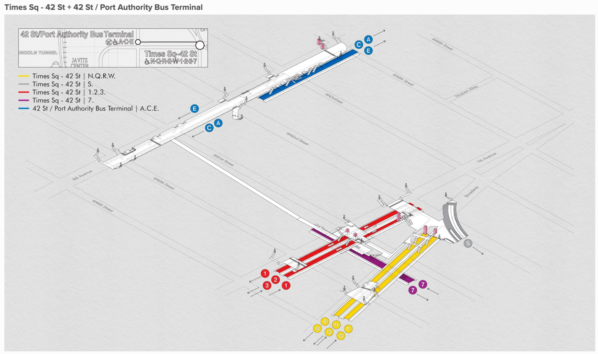
- Outcome variable: ridership (total number of riders that entered a subway complex at the specific hour).
- Related features & supplement datasets:
  - Temporal features: Year, Month, Hour of Day, Day of Week/Is weekend, Season, Holiday, Is NYC School Day (Derived from transit_timestamp in the core dataset).
  - Lagged features: Ridership lag 1h/24h.
  - Weather:
    - Precipitation (Rain/Snow), Temperature:
[https://data.cityofnewyork.us/dataset/Hyperlocal-Temperature-Monitoring/qdq3-9eqn/about_data,](https://data.cityofnewyork.us/dataset/Hyperlocal-Temperature-Monitoring/qdq3-9eqn/about_data) https://www.ncei.noaa.gov/products/land-based-station/local-climatological-data
    - Air quality (AQI): https://data.cityofnewyork.us/Environment/Air-Quality/c3uy-2p5r/about_data, https://a816-dohbesp.nyc.gov/IndicatorPublic/data-features/realtime-air-quality/
  - Unemployment rate: https://fred.stlouisfed.org/series/NEWY636URN
  - MTA fare:
    - January 4, 2026: $3.00
    - August 20, 2023: $2.90
    - March 22, 2015: $2.75
    - March 2013: $2.50
  - Gas price: https://fred.stlouisfed.org/series/DGASNYH
  - Sentiment and satisfaction results: Score from MTA Pulse Survey: (Beginning 2025) https://data.ny.gov/Transportation/MTA-Pulse-Survey-Beginning-2025/5754-yujh/about_data https://metrics.mta.info/?subway/pulsesurvey
  - Safety perception: https://metrics.mta.info/?subway/safety
Proposed Methods
Data Preprocessing and Baselines
We will first align our multi-source external data to the MTA’s hourly reporting intervals. Cyclical temporal features such as Hour and Day of Week will be encoded using sine and cosine transformations to preserve their chronological adjacency, and all continuous variables will be standardized. To establish our baseline performance, we will calculate a historical average heuristic and fit an unregularized Ordinary Least Squares regression. This will quantify the variance explained purely by the standard commuter cycle before exogenous features are introduced.
Predictive Modeling
- Regularized Linear Models: We will deploy Ridge and Lasso regression. Lasso will be used for its sparsity inducing properties, serving to automatically feature select and isolate which supplementary variables yield predictive power vs noise.
- Kernel Methods: Commuter behavior is highly non-linear. We can utilize Support Vector Regression with a Radial Basis Function kernel to natively capture these complex high-dimensional interactions without explicitly engineering polynomial features.
- Ensemble Benchmarks: Tree based models (Random Forest and Gradient Boosting) will be trained as non-linear benchmarks to validate the feature importance hierarchy established by our Lasso model.
Evaluation and Failure Mode Analysis
Models will be evaluated primarily using Mean Absolute Error to prevent unpredictable and extreme ridership spikes from disproportionately skewing the loss surface. Finally we will conduct a rigorous failure mode analysis by examining our residual errors. By isolating the specific timestamps and stations where our best models severely mispredict volume, we will identify systemic blindspots (uncaptured local events or temporal train reroutes), characterize the remaining performance gap, and propose specific data augmentations for future work.

Dataset
- Core datasets:
  - MTA Subway Hourly Ridership 2022 to 2024: This dataset records the hourly turnstile counts and ridership data for the NYC subway system. https://www.kaggle.com/datasets/yaminh/mta-subway-hourly-ridership-2022-to-2024
  - Official NY Open Data (primary sources): https://data.ny.gov/Transportation/MTA-Subway-Hourly-Ridership-2020-2024/wujg-7c2s/about_data, https://data.ny.gov/Transportation/MTA-Subway-Hourly-Ridership-Beginning-2025/5wq4-mkjj/about_data
- The core datasets are filtered under the conditions of:
- transit_mode is subway
- borough is Manhattan
- timestamp: from 2022-05-15 to 2024-05-20, or 2025-01-01 to 2026-02-28.
- Station_complex_id based on selected transportation hub:
Hub Name | Station Complex | station_complex_id
World Trade Center | World Trade Center (E) / WTC Cortlandt (1) | 624
Fulton Center | Fulton St (A,C,J,Z,2,3,4,5) | 628
Grand Central | Grand Central-42 St (S,4,5,6,7) | 610
Penn Station | 34 St-Penn Station (A,C,E) / 34 St-Penn Station (1,2,3) | TBD
Times Sq / PABT | Times Sq-42 St / 42 St-Port Authority (A,C,E,N,Q,R,W,S,1,2,3,7) | 611
Herald Square | 34 St-Herald Sq (B,D,F,M,N,Q,R,W) | TBD

- Outcome variable: ridership (total number of riders that entered a subway complex at the specific hour).
- Related features & supplement datasets:
  - Temporal features: Year, Month, Hour of Day, Day of Week/Is weekend, Season, Holiday, Is NYC School Day (Derived from transit_timestamp in the core dataset).
  - Lagged features: Ridership lag 1h/24h.
  - Weather:
    - Precipitation (Rain/Snow), Temperature:
[https://data.cityofnewyork.us/dataset/Hyperlocal-Temperature-Monitoring/qdq3-9eqn/about_data,](https://data.cityofnewyork.us/dataset/Hyperlocal-Temperature-Monitoring/qdq3-9eqn/about_data) https://www.ncei.noaa.gov/products/land-based-station/local-climatological-data
    - Air quality (AQI): https://data.cityofnewyork.us/Environment/Air-Quality/c3uy-2p5r/about_data, https://a816-dohbesp.nyc.gov/IndicatorPublic/data-features/realtime-air-quality/
  - Population density: ?
  - Unemployment rate: https://fred.stlouisfed.org/series/NEWY636URN
  - MTA fare:
    - January 4, 2026: $3.00
    - August 20, 2023: $2.90
    - March 22, 2015: $2.75
    - March 2013: $2.50
  - Gas price: https://fred.stlouisfed.org/series/DGASNYH
  - Sentiment and satisfaction results: Score from MTA Pulse Survey: (Beginning 2025) https://data.ny.gov/Transportation/MTA-Pulse-Survey-Beginning-2025/5754-yujh/about_data https://metrics.mta.info/?subway/pulsesurvey
  - Safety perception: https://metrics.mta.info/?subway/safety

Citations
https://www.spiedigitallibrary.org/conference-proceedings-of-spie/14064/140644Q/Predicting-subway-ridership-using-machine-learning-and-environmental-factors/10.1117/12.3091914.short
Very similar overall looking at time data, weather and air quality. Used LR, DT, RF, with RF performing the best. No holidays or historic events considered.

https://www.nature.com/articles/s44333-026-00094-4
Less relevant but looks at which stations are most affected by extreme weather events and which types (snow, heat, rain) cause the biggest changes. Totally different methodology though

https://www.sciencedirect.com/science/article/abs/pii/S0965856414002195
Very similar from 2014, uses linear regression, looked more heavily at how different stations are affected by weather including characteristics about the station.

